New Star Aluminium and Steel
Logo

Slogan : create a better life

Mail : newstarfactory1@gmail.com
Contact numbers :
+20106 744 6888, +201158123750
Address : New cairo - Fifth settlement - Thousand factory district - NEWSTAR factory (beside al tayseer mosque )

NS 80
Non-thermal break system

NS 80 system is a parallel sliding three trails system part of NEWSTAR intonation series for windows and doors. It is designed to achieve compatibility between durability and high performance, with a wide range of applications and openings designed to meet the architect's creativity and the client's satisfaction.
The system uses specialized accessories and fittings designed and manufactured specifically for NEWSTAR from the biggest accessories manufacturer in China.

- 3 trails
- Single glazing
- Thickness : 1.2 mm ~ 1.4 mm
- Glass thickness : 6 mm
- Weight : 10 kg/m2
- Net : stainless steel net
- Colour : white / gray

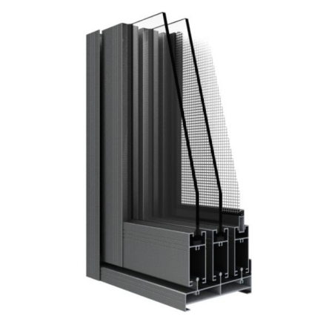

Quality : ⭐⭐⭐⭐⭐
Temperature isolation :⭐⭐⭐⭐
Noise isolation :⭐⭐⭐⭐

NS 100
Non-thermal break system

NS 100 system is a parallel sliding three trails system part of NEWSTAR intonation series for windows and doors. It is designed to achieve compatibility between durability and high performance, with a wide range of applications and openings designed to meet the architect's creativity and the client's satisfaction.
The system uses specialized accessories and fittings designed and manufactured specifically for NEWSTAR from the biggest accessories manufacturer in China.
- 3 trails
- Double glazing
- Thickness : 1.4 ~ 1.5
- Glass thickness : 5mm + 12 mm + 5 mm
- Weight : 14 kg / m2
- Net : stainless steel net
- Colour :white / gray

Quality : ⭐⭐⭐⭐⭐
Temperature isolation :⭐⭐⭐⭐
Noise isolation :⭐⭐⭐⭐⭐
NS 80 jiabaile
Non-thermal break system

NS 80 jiabaile system is an internal sliding two trails system part of NEWSTAR intonation series for windows and doors. It is designed to achieve compatibility between durability and high performance, with a wide range of applications and openings designed to meet the architect's creativity and the client's satisfaction.
The system uses specialized accessories and fittings designed and manufactured specifically for NEWSTAR from the biggest accessories manufacturer in China.
- 2 trails
- Double glazing
- Thickness : 1.4~1.5
- Glass thickness : 5mm + 9mm + 5mm
- Weight : 12 kg/m2
- Net : without
- Colour :white

Quality : ⭐⭐⭐⭐⭐
Temperature isolation :⭐⭐⭐⭐
Noise isolation :⭐⭐⭐⭐⭐

NS 76
Non-thermal break system

NS 76 system is a side hinged system part of NEWSTAR intonation series for doors and windows , It is designed to achieve compatibility between durability and high performance, with a wide range of applications and openings designed to meet the architect's creativity and the client's satisfaction.
The system uses specialized accessories and fittings designed and manufactured specifically for NEWSTAR from the biggest accessories manufacturer in China.
- Side hinged
- Single glazing
- Thickness : 1.4 mm ~1.5 mm
- Glass thickness : 6 mm
- Weight : 7 kg/m2
- Net : without
- Colour :white / gray

Quality : ⭐⭐⭐⭐⭐
Temperature isolation :⭐⭐⭐
Noise isolation :⭐⭐⭐

NS 55
Thermal Break system

NS 55 system is a thermal Break side hinged system part of NEWSTAR intonation series for doors and windows , It is designed to achieve thermal isolation and noise isolation , with a wide range of applications and openings designed to meet the architect's creativity and the client's satisfaction.
The system uses specialized accessories and fittings designed and manufactured specifically for NEWSTAR from the biggest accessories manufacturer in China.
- Side hinged
- Double glazing
- Thickness : 1.4 mm ~1.5 mm
- Glass thickness : 5mm + 12mm + 5mm
- Weight : 14 kg/m2
- Net : stainless steel net
- Colour : white / gray

Quality : ⭐⭐⭐⭐⭐
Temperature isolation :⭐⭐⭐⭐⭐
Noise isolation :⭐⭐⭐⭐⭐

NS Aluminum door cover

NS Aluminum door covers is a framing system for the internal doors and windows, designed to meet the architect's creativity and the client's satisfaction. The system uses specialized materials designed and manufactured specifically for NEWSTAR from the biggest manufacturer in China.

- Thickness : 1.2 mm ~ 1.4 mm
- Color : white

NEW STAR aluminum accessories

Mail : newstarfactory1@gmail.com
Contact numbers :
+20106 744 6888, +201158123750
Address : New cairo - Fifth settlement -
Thousand factory district - NEWSTAR factory
(beside al tayseer mosque )

